**Graphics and Animation Tools**

**LAB**

**VIVA-2**

**Snowfall mountain using GIMP**

**Step-1**

Go to File → New to open a blank canvas.

**Step-2**

Select the paint tool and color the background (here light blue).

**Step-3**

Select the paint brush tool and reduce the hardness and force and draw the mountain with random curve lines.

**Step-4**

Select Acrylic 02 (180 x 180) and increase the size to 500-600 and switch the color to white and use to give effect of the cloud.

**Step-5**

Select Acrylic 01 (180 x 180) and decrease the size to around 10 and switch the color to white and use to give effect of the snow laid on the surface of the mountain.

**Step-6**

Select Acrylic 01 (180 x 180) and decrease the size to around 2-3 and switch the color to white and use to give effect of the snowfall in the air.

**Output-**

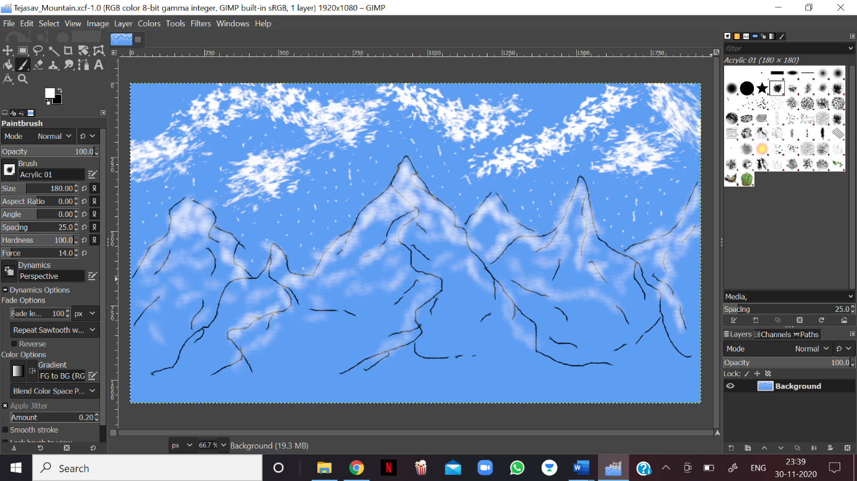

**Skyscraper Using Blender**

**Step-1**

Create a new project and clear everything from the interface.

**Step-2**

Go to Add → Mesh and add a cube and go to edit mode then face select mode and then extrude (E) the face to create the base of the skyscraper.

**Step-3**

Select all the face on the top of the building the extrude it to increase the height of building.

**Step-4**

Repeat the Step-3 with less number of face every time to get the look of the skyscraper.

**Step-5**

Color the same according to your choice.

**Output-**

